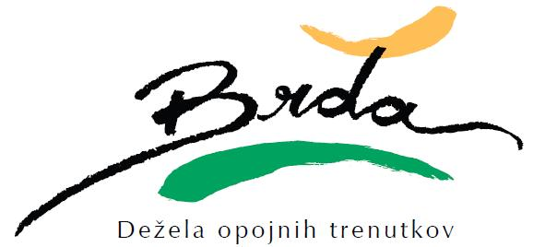
TOURIST GUIDES
 | Name and surname | Telephone num | Languages
 |  |  | SLO | ANG | ITA | NEM | HR | ŠP
1 | Bašin Tatjana | 041 341 149
2 | Bevc Ljubomira | 051 824 704
3 | Erzetič Nina | 040 348 538
4 | Kolenc Marja | 041 762 729
5 | Lipicer Anka | 051 386 448
6 | Marc Robert | 040 363 545
7 | Marinič Peter | 051 310 413
8 | Mavrič Eva | 031 341 693
9 | Mugerli Boštjan | 031 286 933
10 | Prinčič Nevenka | 040 799 422
11 | Ribolica Kavčič Sanja | 031 852 067
12 | Simčič Aleks | 031 261 077
13 | Simčič Helena | 031 857 755

